# Section 9 Assignment (108 POINTS) – Boolean Functions

To receive credit, you must either show your work on the worksheet or explain how you got the answer.

96/108

1. (12 points) Draw the arrow diagram and the matrix representation for each relation.
   1. (6 pts) The domain for relation R is {1, 2, 3, 4}

R = { (1, 2), (1, 4), (2, 2), (2, 1), (4, 1), (4, 2), (4, 3), (4, 4)}

1

2

3

4

1

2

3

4

1 2 3 4

1 0 1 0 1

2 1 1 0 0

3 0 0 0 0

4 1 1 1 1

* 1. (6 pts) The domain of relation P is {1, 2, 3, 4, 5}

For x, y in the domain, xPy if $⌈\frac{x}{y}⌉>1$

R = {(2,1),(3,1),(3,2),(4,1),(4,2),(4,3),(5,1),(5,2),(5,3),(5,4)}

1

2

3

4

5

1

2

3

4

5

1 2 3 4 5

1 0 0 0 0 0

2 1 0 0 0 0

3 1 1 0 0 0

4 1 1 1 0 0

5 1 1 1 1 0

1. (18 points) For each relation, indicate whether the relation is:

* reflexive, anti-reflexive, neither,
* symmetric, anti-symmetric, neither, both
* transitive or not transitive

|  |  |  |  |  |
| --- | --- | --- | --- | --- |
|  | 1 | 2 | 3 | 4 |
| 1 | 0 | 1 | 1 | 1 |
| 2 | 1 | 1 | 0 | 0 |
| 3 | 0 | 0 | 1 | 0 |
| 4 | 1 | 0 | 1 | 1 |

1. (6 pts)

neither, anti-symetric, not transitive

4/6 it is neither anti-symmetric nor symmetric

1. (6 pts)

|  |  |  |  |  |
| --- | --- | --- | --- | --- |
|  | 1 | 2 | 3 | 4 |
| 1 | 1 | 1 | 0 | 1 |
| 2 | 1 | 1 | 0 | 0 |
| 3 | 0 | 0 | 1 | 1 |
| 4 | 1 | 0 | 1 | 1 |

reflexive, both, not transitive

4/6 not anti-symmetric

|  |  |  |  |  |
| --- | --- | --- | --- | --- |
|  | 1 | 2 | 3 | 4 |
| 1 | 1 | 0 | 0 | 0 |
| 2 | 0 | 1 | 0 | 0 |
| 3 | 0 | 0 | 1 | 0 |
| 4 | 0 | 0 | 0 | 1 |

1. (6 pts)

reflexsive, symmetric, transitive

4/6 is anti-symmetric

For all of these apparently I just didn't get what anti-symmetric meant.

1. (6 points) Determine whether the relation R on the set A is an equivalence relation

A = {a, b, c}, R = { (a, a), (a, c), (b, b), (c, a), (c, c)}

**no because it is not transitive**

**I guess didnt really understand what was being asked here.**

1. (10 points) Figure 1 shows a directed graph (digraph).

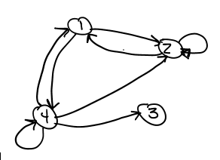

Figure 1

* 1. (2 pts) What is the in-degree of vertex 4?

2

* 1. (2 pts) What is the out-degree of vertex 4?

4

* 1. (2 pts) What is the head of edge (4, 3)?

3

* 1. (2 pts) What is the tail of edge (4, 2)?

4

* 1. (2 pts) List all self-loops in the graph, if any:

**(4,4), (2,2)**

**zyBook defines a path as a succession of edges and vertices with no repeating edge or vertex. (Section 9.3). The textbook indicates the vertices <and the edges for that matter> don't have to be distinct. (Chapter 4.3).**

**Question 5 and 6 uses the zyBook definition:**

1. (6 points) WALK/TRAIL/PATH in Figure 1
   1. (3 pts)

Is ⟨1, 2, 4, 1⟩ a walk in the graph? no

Is it a trail? no

Is it a path? **no**

Figure 1

* 1. (3 pts)

Is ⟨4, 2, 2, 1⟩ a walk in the graph? yes

Is it a trail? yes

Is it a path? no



1. (6 points) CIRCUIT/CYCLE in Figure 1
   1. (2 pts)

Is ⟨2, 1, 4, 2⟩ a circuit in the graph? yes

Is it a cycle? yes

* 1. (2 pts)

Is ⟨2, 1, 2, 1, 2, 1⟩ a circuit in the graph? no

Figure 1

Is it a cycle? no

* 1. (2 pts)

Is ⟨4, 4, 2, 2, 1, 4⟩ a circuit in the graph? yes

Is it a cycle? no

1. (20 points) Figure 2 shows a graph G. Draw G2, G3, and G4. Then take the union of all of the graphs (including G) to get G+

G^2 G^3

4

3

2

1

2

4

3

1

Figure 2

G^4 G^+

2

1

2

1

4

4

3

3

**Some of the arrows got moved for some reason so I put them back where they were, but I promise I didn’t move them from where they originally where.**

**zyBook defines a path as a succession of edges and vertices with no repeating edge or vertex. (Section 9.3). The textbook indicates the vertices <and the edges for that matter> don't have to be distinct. (Chapter 4.3).**

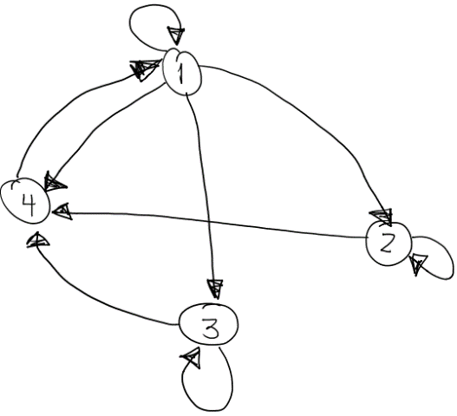

Figure 5

1. (10 points) For the digraph in Figure 5,
   1. (5 pts) List all TEXTBOOK paths of length 3 starting from vertex 2

2,2,2,2 2,2,2,4 2,2,4,1 2,4,1,1

2,4,1,4 2,4,1,2 2,4,1,3

* 1. (5 pts) List all ZYBOOK paths of length 3 starting from vertex 2

2,4,1,3

|  |  |  |  |
| --- | --- | --- | --- |
| A = | 3 | 3 | 1 |
|  | 6 | -2 | 0 |

|  |  |  |  |
| --- | --- | --- | --- |
|  | 2 | 2 | -1 |
| B = | 8 | 7 | 3 |
|  | 4 | -1 | 4 |

For question 9 let…

|  |  |  |  |
| --- | --- | --- | --- |
|  | 1 | 1 | 0 |
| C = | -3 | 2 | 2 |
|  | 6 | 5 | 1 |

|  |  |  |  |
| --- | --- | --- | --- |
|  | 9 |  | 2 |
| D = | 5 |  | 4 |

1. (20 points) If possible, compute each of the following:
   1. (4 pts) B + C

|  |  |  |
| --- | --- | --- |
| 3 | 3 | -1 |
| 5 | 9 | 5 |
| 10 | 4 | 5 |

* 1. (6 pts) BA

Not possible

* 1. (8 pts) AD

not possible